

Guidance and support for parents and carers of children and young people who are self-harming

**Understanding your child’s self-harm**

# **Contents**

What is self-harm …………………………………………………………………………………………………………… 3

Reasons why children/young people self-harm ………………………………………………………………. 4

Myths around self-harm …………………………………………………………………………………………………. 5

How and when to support someone who is self-harming ……………………………………………….. 6

Talking to your child about self-harm ………………………………………………………………………………10

Self-care for you ………………………………………………………………………….. …………………………………12

Local and national resources and support ……………………………………………………………………….13

# **What is the aim of this booklet?**

The aim of this guide is to help you as a parent or carer have a better understanding of what your child may be going through when they choose to harm including: how to support them, how to look after yourself, local and national support.

# **Why is this booklet necessary?**

[Public Health Profile data](https://fingertips.phe.org.uk/search/Intentional%20Self%20Harm#page/3/gid/1/pat/15/par/E92000001/ati/6/are/E12000009/iid/21001/age/1/sex/4/cat/-1/ctp/-1/yrr/1/cid/4/tbm/1) show that in 2021/22 the South West had the second highest rate of emergency admissions for intentional self-harm compared to all English regions. Self-harm was identified as a priority area in South Gloucestershire Council’s 2023 Children and Young People’s Needs Assessment. Early intervention strategies were a specific recommendation. This booklet is a first step in helping address the issue.

# **How this booklet may help**

It can be difficult to know what to do when you find out that your child is harming themself. As a parent/carer you may feel angry, shocked, guilty, upset or a mixture of emotions. These feelings are normal reactions, national advice suggests children with self-harming behaviours need parents and trusted adults in their life to stay calm and listen to them. It can be a long journey, but with the right help and support you can enable more positive ways to cope.

Thank you to everyone who has inputted into the booklet including; South Gloucestershire Public Health, Off the Record, Mental Health Support Teams, South Glos Parents and Carers, school nursing team and CAMHS.

Updated January 2025

# **What is self-harm?**

Self-harm is when someone causes harm to themselves, usually as a way to help cope with difficult or distressing thoughts, feelings or situations. It can be any behaviour that causes injury – no matter how minor or low-risk.

## Examples

* Self-cutting
* Taking an overdose
* Swallowing objects or poisons
* Hitting or bruising
* Self-strangulation with ligatures
* Burning
* Not taking prescription medication

*In under 11-year-olds self-harm may present differently:*

* Scratching
* Picking scabs
* Head-banging

## Self-harm Cycle

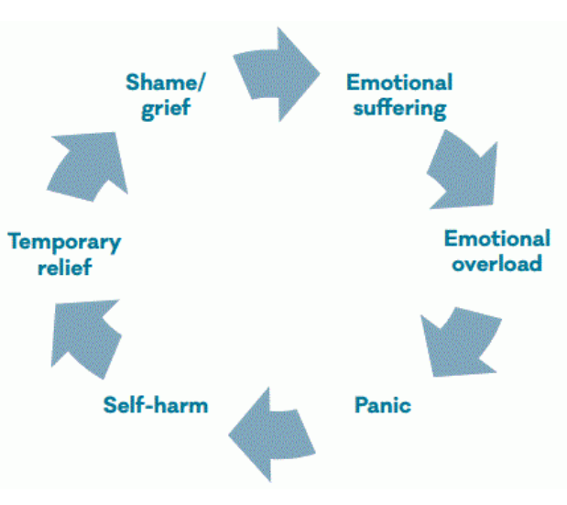

*Image taken from Mental Health Foundation* [The truth about self-harm | Mental Health Foundation](https://www.mentalhealth.org.uk/explore-mental-health/publications/truth-about-self-harm)

Self-harm usually starts as a way to relieve the build-up of pressure from distressing thoughts and feelings – it may offer the person a temporary relief from what they are experiencing. The relief is only short term, as the underlying reasons for the initial distress are still there. After the act of self-harm, feelings of shame and guilt may occur which can lead to the continuation of the self-harm cycle.

Self-harm can become a person’s ‘normal’ way of dealing with the difficult situations they experience because of that short term relief they feel. Talking to someone about their self-harm and helping them with learning new coping strategies can help them to deal with difficulties in a more positive way, making it easier to break the self-harm cycle long-term.

# **Reasons why children / young people self-harm**

There are lots of reasons why a child or young person may self-harm and they will be different for everyone. When we are unable to express our thoughts and feelings through effective coping strategies, these emotions can build up and become unbearable. Self-harming can be a way of letting those feelings out, some children or young people want a quick release of those feelings. If those emotions are making you feel a numbness it can be a way of being able to feel something physically.

## Some of the reasons for self-harming

* To manage emotional upset
* To reduce tension
* To relocate the emotional pain into a physical pain i.e. physical pain that has a known cause (for example a cut) is more tolerable than mental pain for which the cause is less understandable
* To express emotions such as hurt, anger or frustration
* An expression of abuse or harm from another person
* A form of escape
* An effort to regain control over feelings or problems
* An attempt to punish oneself or others
* To elicit care from others
* To identify with a peer group

In some cases, self-harm can be a suicide attempt. Some young people who are self-harming may also experience suicidal thoughts. For more information and support [Suicidal Feelings | Help And Advice For Young People | YoungMinds](https://www.youngminds.org.uk/young-person/my-feelings/suicidal-feelings/) or for training around suicide awareness [Free online training from Zero Suicide Alliance](https://www.zerosuicidealliance.com/training)

Self-harm can affect anyone, all ages and backgrounds. But there are circumstances and experiences that make people more likely to self-harm. There are some communities who encounter these more; for example, the discrimination and stigma members of the LGBTQ+ community experience, and racial discrimination experienced by different ethnic groups. Self-harm levels are also higher in people who are neurodiverse. People may self-harm because they are treated badly. Everyone is worthy of respect and deserves help.



*Image from Young Minds* [Self-harm | Advice for young people | Get help | YoungMinds](https://www.youngminds.org.uk/young-person/my-feelings/self-harm/#Gethelpnow)

# **Myths around self-harm**

There are a lot of myths surrounding self-harm, due to a lack of understanding, and this leads to people not being comfortable to speak about their self-harming behaviour. Professionals, family or friends may not understand those who self-harm or know how to approach the conversation and can inadvertently judge or shame.

## ‘Self-harm is attention seeking’

This is one of the most common misconceptions around self-harm. Most self-harmers do not tell anyone about what they are doing and what they are going through for a long time and will often hide any physical signs of the harming behaviour. It takes a lot of courage for someone to ask for help with their self-harming.

## ‘Self-harm always leads to suicide’

Self-harm can be thought of as a suicide attempt by those who do not understand it. However, children and young people use self-harm as a way of coping with emotional stress and difficult feelings and situations. It is a way of seeking relief from what is happening to them at that time.

## ‘It is only girls who self-harm’

Research shows that boys are also self-harming. The self-harm act tends to be different between boys and girls with boys tending to be more aggressive for example hitting something or smashing things which tends to lead to hand injuries. This leads to it being harder to pick up in boys as the actions gets passed off as ‘boys being boys’. Self-harm can affect anyone regardless of their gender, sexuality and ethnicity.

## ‘People who self-harm must enjoy it’

The harmful behaviour a child or young person undertakes tends to cause them great physical pain. It can be about them feeling something to remind them they are alive if they are feeling numb from depression, or about feeling physical pain to take away from the mental pain. There is no evidence that children or young people who self-harm take pleasure from the act. It can become a habit for them and the only way they are able to cope with the emotions they are feeling.

# **How and when to support someone who is self-harming**

Firstly, it is important to try not to panic. Evidence or disclosure of self-harming behaviour can feel overwhelming, and this is a normal reaction to finding out your child is harming themselves. Try and remain calm.

If they have opened up to you themselves thank them for trusting you and asking for help. If you have discovered they are harming do not question them on why they haven’t opened up but reassure them they do not have to talk about it now, but you are there for them as and when they are ready.

Recognise it may be necessary to deal with any physical injuries caused by the self-harm, whether this is by yourself or, if more severe, seek medical attention. For more information around basic first aid for self-harm injuries [First Aid | Self Injury Support](https://www.selfinjurysupport.org.uk/Pages/FAQs/Category/first-aid).

If you are unsure on how to deal with the injuries or are not confident in dealing with them please seek medical advice from GP, pharmacy, 111, Minor Injury Unit. If the injuries are life threatening please call 999.

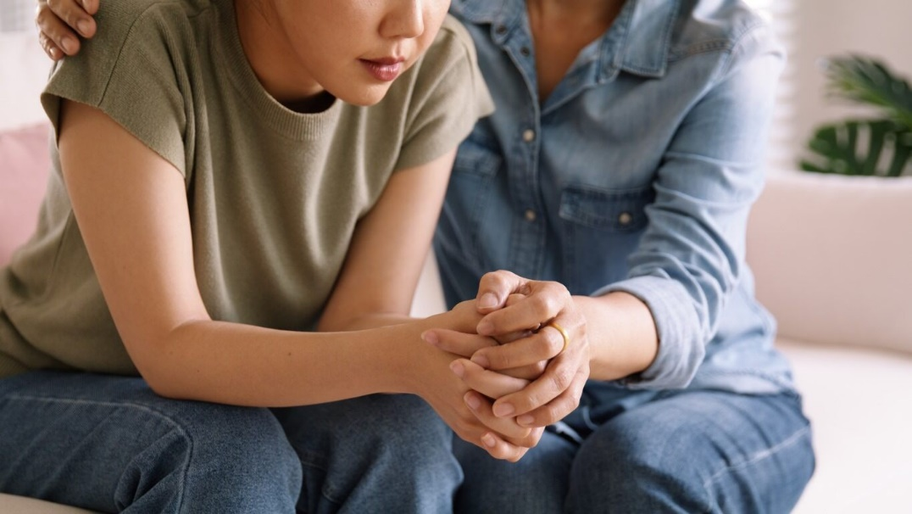

# 

There are a number of ways of supporting your child who is self-harming:

## Listen and be non-judgemental

Listening in an open and non-judgemental way is key. Being a safe space for them to express how they are feeling will help your child to open up. Take what they are saying seriously, do not shame or judge them for the thoughts and feelings they are experiencing. What triggers your child to harm may seem small or confusing to you but to them it is a huge cause of distress. By asking curious questions your child will feel heard, validated and can help you to understand what they are going through.

## Help them to manage their feelings

Talk through their feelings with them and help them to recognise what they are feeling physically and emotionally when the urge to self-harm arises. Help them to build up a support network – who can they turn to for help and support when they are experiencing these feelings. This could be friends, family, a member of school staff, youth worker etc. Also letting them know there are support lines and apps they can use in moments of need.

## Remind them of other ways to cope

Work with them to come up with other way to cope, to distract from the urge to harm. Encourage them to think about trying to delay the act of self-harm and have as much control as possible. For example, replacing the act with a method that causes less/minimal injury – flicking elastic bands on the wrist, holding onto an ice cube.

Over time they will begin to replace the act of harming with a more positive activity which needs to be something they are interested in and can help dial down the distressful thoughts and feelings. Some examples include;

* Having a bath
* Doing a form of physical activity
* Getting out of the house and into nature
* Watching the TV or a film
* Reading a book
* Caring for a pet
* Listening to music
* Mindfulness / breathing techniques
* Being creative
* Meet up with friends
* Do an activity with family members
* Speak to friend/family on the phone or online

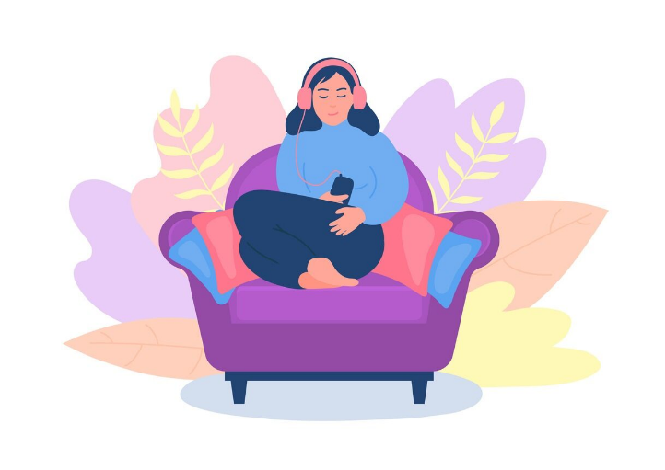

Make the examples personal to your child, these are just examples. Take the lead in suggesting some ideas which you know your child is interested in and then get them to build on them.

## Harm minimisation

Even when your child opens up and talks about their self-harming, they are not instantly going to be able to stop. Harm minimisation involves thinking of ways to reduce the risk and making it as safe as possible when they do self-harm. Get them to think about the environment they are in when they are harming, ensuring they are using a clean blade if cutting, having medical supplies to hand to deal with the injuries caused and practising wound care. It may also be about talking to them about safer areas of the body to carry out the harming act, for example rather than cutting at the wrists turning their arm over and cutting more towards the elbow leading to less chance of accidentally hitting an artery.

It can be difficult to get your head around teaching them to harm themselves safely but stopping self-harm is a long process and it is about them being as safe as possible while they are still harming.

## Take talk of suicide seriously

If they mention suicide take them seriously. Ask them whether they have made plans to end their life. If they disclose they have made plans or have suicidal intent, try and remain calm and listen to what they are telling you. There is help at hand from the CAMHS 24 hour mental health response line 0800 953 9599 this will connect you to a CAMHS practitioner [I need help now :: Avon and Wiltshire Mental Health Partnership NHS Trust (awp.nhs.uk)](https://www.awp.nhs.uk/camhs/help-now)

Suicide awareness training can be accessed through the Zero Suicide Alliance for free and only takes 20 minutes but will equip you to have this conversation [Free online training from Zero Suicide Alliance](https://www.zerosuicidealliance.com/training)

## Create barriers to make it more difficult to self-harm

Along with them work out ways to make it more difficult for them to self-harm. This may be safer storage of medicines, removing sharp objects etc. However, do not do this in isolation as it may increase your young person’s level of distress but can be helpful done alongside other strategies mentioned.

## Recognise their triggers

Talk with them about triggers that lead them to self-harm which you can watch out for and help them negotiate. These could be bullying both in person and online, abuse, stressful situations for example exams. There are also signs you can look out for that might indicate they are self-harming:

* Withdrawing or isolating from social situations
* Signs of low mood or depression, tearful, lack of motivation
* Mood changes i.e. more aggressive
* Changes in eating / sleeping habits
* Talking negatively about themselves
* Abusing alcohol or substances
* Expressing feels of failure, loss of hope
* Risk taking behaviours
* Unexplained marks and bruises
* Covering their bodies up
* Personality change i.e. quieter than normal
* Lacking energy

## Make a safety plan

It can be useful to put everything you have talked about and ideas you have come up with into a safety plan. The plan can include the warning signs, techniques to distract away from self-harming, strategies they can use to help calm them, how other people can help, who they would like to know and be involved, who to contact in an emergency and when to contact A&E. Here is a link to a template safety plan [SAFETY PLANNING (distresscentre.com)](https://www.distresscentre.com/wp-content/uploads/2023/01/safety-planning-clouds-final.pdf)

It is worth talking to your child about who they would like to share the safety plan with for example school, out of school clubs, other family members, friends.

It is important to remember you do not have to cover all of these things all at once as that would be overwhelming for your child and yourself. Dealing with self-harm is a long, slow process that will be worked on over time. Unfortunately, there isn’t a one size fits all and some of these things will work for your child and some won’t. It is about working with them and trying different things to see which have the most impact. It also has to come from them you cannot tell them what to do but help guide them to the methods that work best for them. Remember you are not alone and there is lots of help, support and resources available to you (listed at the end of this guide).

# **Tips for talking to your child about self-harm**

* Make sure you are in a location where your child feels comfortable and there isn’t a chance of interruption.
* Ensure you have made time to have the conversation, so it does not feel rushed or time pressured.
* If you can remove all distractions, for example phones, be able to give your full attention to the conversation and be fully present with your child.
* Thank them for opening up and acknowledge that you understand that it is difficult to talk about their self-harm but it is a brave thing to do and they can take their time. It will be a long process and you will not be able to talk through or solve everything in one go.
* Let your child take the lead and allow them to open up as much or little as they feel comfortable with.
* Position yourself to the side of your child rather than face on as this helps them to open up. Consider having the conversation while out for a walk so you are side by side or even while doing an activity for example baking, cooking, crafting.
* Think about the timing of the conversation- it doesn’t need to happen at the point of harming at this point the focus is dealing with any injuries and regulating/calming your child.
* Try not to focus on the specific methods or injuries but on their feelings and what they are going through. Explore situations that increase their urge to self-harm. When was the last time they harmed, where were they.
* It can be difficult to hear that your child is hurting themselves try not to act shocked, disgusted or ashamed by what you are hearing. This reaction will lead to them feeling shamed by their action and will put them off opening up again. Focus on what they are feeling.
* You may not understand what they are going through or why they are harming themselves but let them know that you are there for them when they need to talk.
* Be prepared with sources of support that they can access when they feel ready, let them know that they are not alone. Don’t force them to seek help if they are not ready.
* As much as you want them to stop hurting themselves telling them to stop will be counterproductive and may stop them opening up again.
* Be positive, let them know they have taken a massive step by opening up and that there is support available and recovery is possible, but it will be a long process and there will be bumps in the road. Reassure them that you are there to help them at each step.



There is a chance your child is not ready or able to talk about their self-harming. This can be difficult and frustrating when you want to be able to help them. Take a step back and let them know that you are there for them and ready to listen whenever they are ready to talk. Let them know there are other people they can talk to if they would prefer (see the local and national support section).

Don’t let the self-harm change the relationship you have with them and ensure that you are not bringing it up with them all of the time. When they are ready, they will hopefully come to you. You can ask if they are talking to anyone else but try not to pry or ask that person for information.

Try and open up conversation around wellbeing in general, talk about how you cope with your wellbeing and what you do to manage stressful situations. Keep this light and general, don’t go into too much detail about your stressors as you do not want to put that onto your child.

These are difficult conversations to have and can feel very intense for both you and your child. Natural conversation can make it easier and less forced and put you both at ease. Doing an activity alongside each other can also encourage conversation and help the person to open up for example walking, jogging, baking, crafts, gaming. When they are relaxed, they may naturally open up to you about what they are going through.

# **Self-care for you**

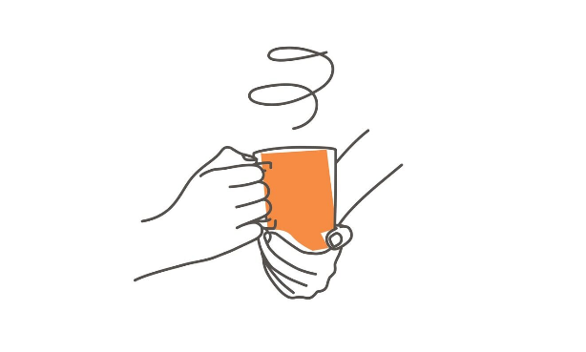

Supporting your child who is self-harming is not a quick and easy task. It can be a long process with lots of ups and downs along the way. It is important to ensure you are also taking care of yourself or you will be no help to your child – like when on an aeroplane ‘place your own oxygen mask on first before helping others’.

It is important that you also have a trusted person you can talk to, especially when things become overwhelming and if you start to struggle to cope. This could be a family member, friend, counsellor or as part of a support group.

Be realistic about how much you can take on and set boundaries. You are not going to be able to solve all of the problems and that is ok. Taking a break is ok and is necessary to ensure you have time for yourself to do something that maintains your mental and physical wellbeing. This may feel selfish and hard to do when your child is suffering but you are no use to anyone if you are running on empty.

For help with your own mental wellbeing please see our One You South Glos website [For Your Mind | One You South Gloucestershire (southglos.gov.uk)](https://oneyou.southglos.gov.uk/stress-less/)

[NHS Talking Therapies](https://www.vitahealthgroup.co.uk/nhs-services/nhs-mental-health/bristol-north-somerset-and-south-gloucestershire-mental-health-services/) offer a range of webinars, group and one to one support so you do not need to go through this alone.

South Glos Parents and Carers (SGPC) offer support, resources and groups for parents and carers of children and young people with Special Educational Needs and Disabilities [South Glos Parent Carers (sgpc.org.uk)](https://sgpc.org.uk/)

# **Local and national support**

There is lots of help and support locally and nationally, so you are not alone and neither is your child.

## Local support

**School Nurse –** school nurses work with children, young people and their parents/carers to maximise their health and wellbeing [School Nursing Service – Children and Young People’s Services (sirona-cic.org.uk)](https://sirona-cic.org.uk/children-services/services/school-nursing-service/)

**ChatHealth –** confidential text messaging service where a young person can speak to a school nurse **07312 263093** [ChatHealth – Children and Young People’s Services (sirona-cic.org.uk)](https://sirona-cic.org.uk/children-services/services/chathealth/)

**Off the Record –** is a mental health social movement by and for young people aged 11-25. They run a variety of drop ins, groups, 1:1 support and much more. [Home - OTR (otrbristol.org.uk)](https://www.otrbristol.org.uk/). They provide groups like MindAid and Resilience Lab where young people can learn coping skills. Resilience Lab is run within most South Glos Secondary Schools.

**Kooth –** is an online mental wellbeing community for young people aged 11-18 years. It provides free, safe and anonymous support. There is 1:1 support from an online counsellor, forums, articles, activities and much more. [Home - Kooth](https://www.kooth.com/)

**GP –** you can make an appointment to visit your doctor or nurse to talk through worries or concerns or receive treatment for any self-harm injuries.

**CAMHS –** is the mental health service for children and adolescence. Their website contains lots of information and support [Local community CAMHS :: Avon and Wiltshire Mental Health Partnership NHS Trust (awp.nhs.uk)](https://www.awp.nhs.uk/camhs/camhs-services/camhs-locality)

**NHS Talking Therapies –** provide free support to people over the age of 16. There isn’t a need for a referral you can contact the service via the digital assistant on the website, online form or by phone. [NHS Talking Therapies - North Somerset & South Gloucestershire (vitahealthgroup.co.uk)](https://www.vitahealthgroup.co.uk/nhs-services/nhs-mental-health/bristol-north-somerset-and-south-gloucestershire-mental-health-services/)

## National support

**Harmless –** works to address and overcome issues related to self-harm and suicide. They work with the person who is self-harming, family and friends, people in crisis. [Home - Harmless](https://harmless.org.uk/)

**Young Minds –** provides lots of support and information around self-harm and other mental health conditions for the young person themselves, parent/carers or professionals. [Self-harm | Advice for young people | Get help | YoungMinds](https://www.youngminds.org.uk/young-person/my-feelings/self-harm/#Gethelpnow)

**The Mix –** is a digital charity for under 25s, they provide free, confidential and anonymous support. They help young people take on any challenge they are facing. [The Mix - Essential support for under 25s](https://www.themix.org.uk/)

**Self Injury Support –** provide support for women and girls[Self Injury Support](https://www.selfinjurysupport.org.uk/)

**Childline –** support for anyone under 19, help and advice on a wide range of issues. Talk to a counsellor on the phone (0800 1111) or online, send an email or post on the message board [Childline | Childline](https://www.childline.org.uk/)

**SHOUT –** text based messaging support service for anyone who is struggling to cope. Text SHOUT to 85258 24/7 [Shout - UK's 24/7 Crisis Text Service for Mental Health Support | Shout 85258 (giveusashout.org)](https://giveusashout.org/)

## Resources

There are a number of resources avaliable to help children and young people with their general mental health and wellbeing:

The CAMHS website has a range of resources and apps avaliable [Wellbeing Resources :: Avon and Wiltshire Mental Health Partnership NHS Trust (awp.nhs.uk)](https://www.awp.nhs.uk/camhs/things-you-need-know/camhs-wellbeing-resources)

Reading Well offers a range of books that help children and young people understand and manage their mental health [Reading Well booklists | Books | Reading Well (reading-well.org.uk)](https://reading-well.org.uk/books/books-on-prescription) all South Glos libraries stock these books.

Calm boxes contain things that ground you, make you feel more relaxed and reduces symptoms of panic, anxiety or low mood. [How to Make a Self-Soothe Box | Young Person Blog | YoungMinds](https://www.youngminds.org.uk/young-person/blog/how-to-make-a-self-soothe-box/)

A silhouette of a person's head

